Team 2

Cody Reid

Daniel Anishchenko

Cuauhtemoc Gomez Angeles

Tyler Tran

10/12/2024

**Idea 1**

**Description:** A motorcycle helmet LED array attachment that connects to the back of the helmet. When the user begins to brake, the LEDs blinks rapidly, letting anyone driving behind the motorcyclist know that they are coming to a stop. Also, a haptic feedback inside the helmet, letting the rider know if they are approaching an object or an object is approaching them too quickly.

**Senors:** Accelerometer, and ultrasonic or laser ranging,

**Controller:** ESP32

**Actuators:** Vibration and LEDs

**Initial Drawing:**

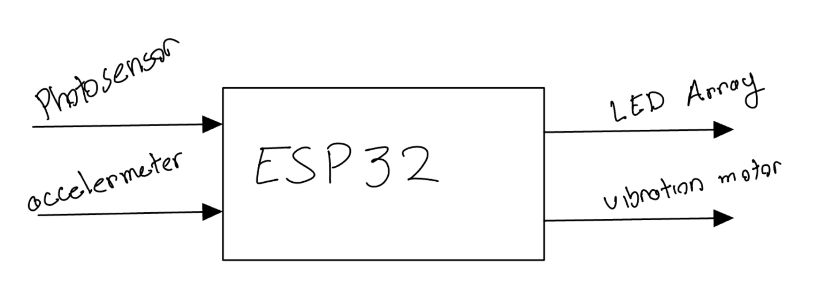

**Idea 2**

**Description:** Alkaline battery recharger. Allowing users to recharge lithium ion button cells and alkaline batteries. Temperature sensors and timers keep the batteries charging safely and the battery ejector ejects them from the charging tray when they are fully charged or will no longer charge.

**Senors:** Thermal sensors, voltage sensors

**Controller:** ESP32

**Actuators:** Battery ejection solenoid, charging status LEDs

**Initial Drawing:**

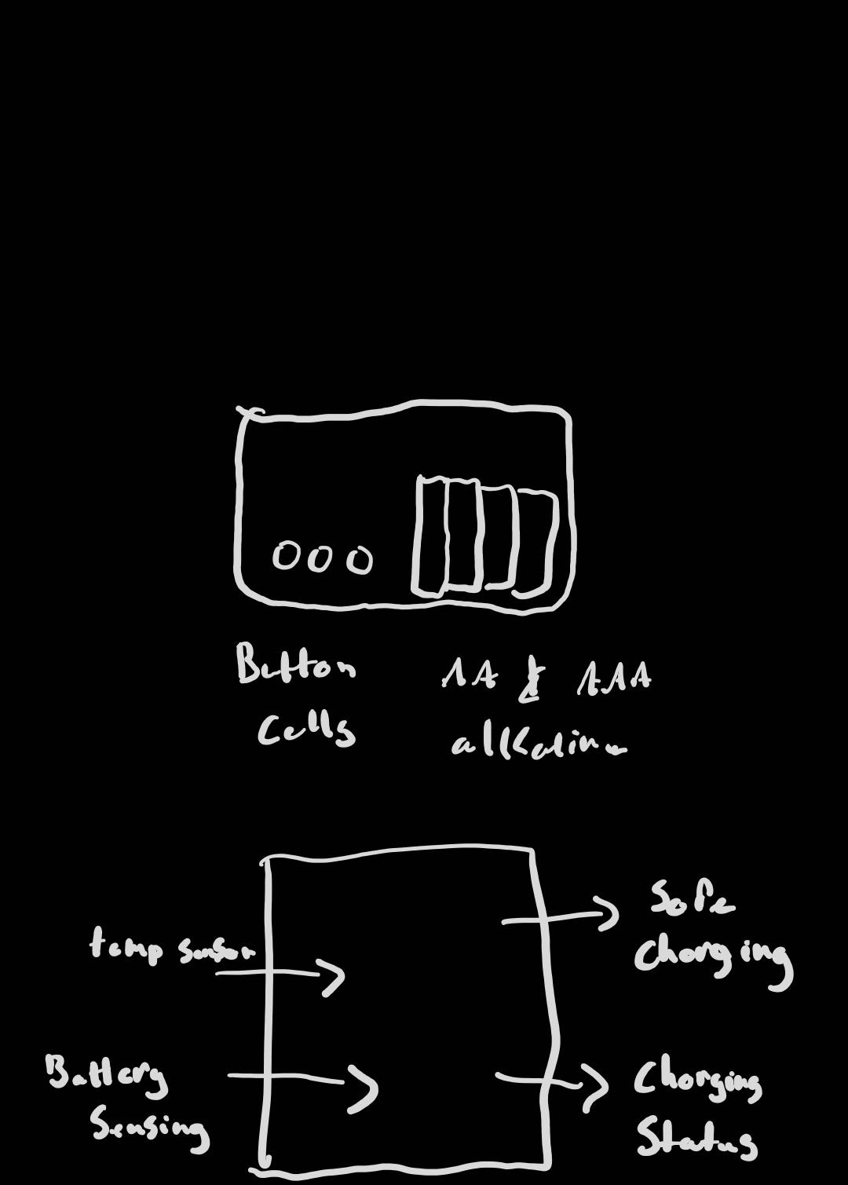

**Idea 3**

**Description:** Automated Irrigation System that utilizes a microcontroller to control the parameters related to farming, such as water flow control, element measurement (temp, TVOC, eCO2, etc),

**Senors:** Multi Environment Sensor, Moisture Sensor

**Controller:** ESP32/Arduino R4 Wifi

**Actuators:** Water Pump, Solenoid (hazard protection)

**Initial Drawing:**

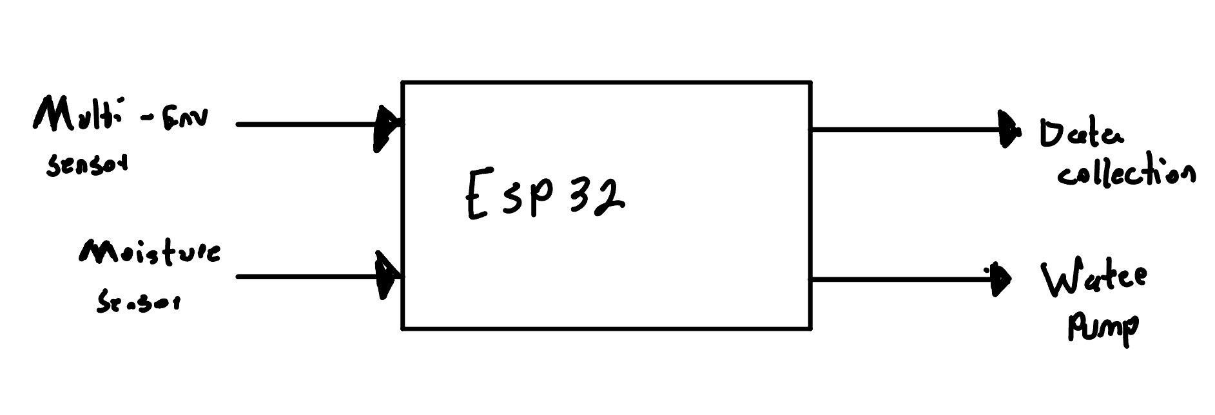

**Choice: Idea 2**

**Project Name :** ChargeGuard Pro+

**Reasons:**

* This concept can safely charge both alkaline and lithium-ion button cell batteries addresses a gap in the market because many chargers are limited to specific battery types
* Both of these battery types can help reduce waste by reducing the rate of disposal
* With the built in temperature sensor, timers and ejector, this product will be user friendly and convenient
* There is a growing demand for rechargeable batteries